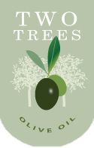

Two Trees Olive Oil

888 Two Trees Drive

Ithaca, New York 14850

**Employee Verification**

My signature below is my affirmation that I have reviewed and understand the contents of the current version of the Two Trees Olive Oil employee handbook, dated April 15, 2010.

|  |  |
| --- | --- |
|  |  |

olivetree_v1